Gerry Lavalley
May 27, 1938 – May 7, 2020
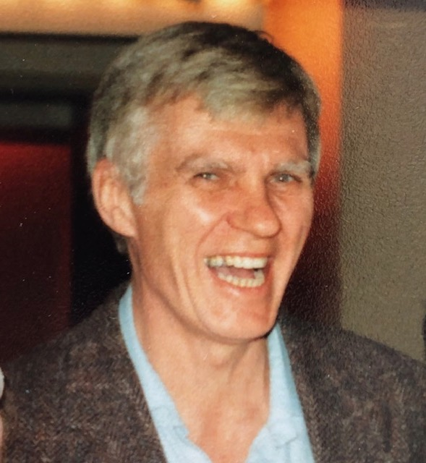
It is with deep sadness that we announce the passing of Gerry Lavalley.

Gerry died at Lakeshore Hospital in the early hours of May 7 following a long and stoical struggle with COPD (emphysema).

Gerry was our paterfamilias in the department of Humanities/Philosophy/Religion and one of the originals from 1971 at Abbott. Over his 32 year career, he played many roles: he was usually a co-chair, a founder of the Liberal Arts program, and always the anchor of the department. He was deeply loved. He was a passionate champion of what he believed and never suffered fools gladly. His classroom and office were the site of high spirits and laughter; he was everyone’s mentor – students and colleagues alike. Yet he wore his charisma lightly.

Gerry worked for many years in architecture in St. John, N. B. and then Montreal so that he could return to university at Sir George Williams to study philosophy and mathematics. His Master’s thesis was on the epistemological implications of Einstein’s theory of relativity. One of his professors, Andrew Kofechek, said Gerry was the closest to Plato’s philosopher king he’d ever met. Gerry was eternally and humbly grateful for the life of a teacher and thinker; he felt sprung from the corporate rat race.

He lived with gusto and boundless curiosity. His courses ranged widely, from the history of Philosophy, to Math and Logic for Liberal Arts students, and Oriental Philosophy. He loved teaching, Kant, Siamese cats, Go, Zen Buddhism, jazz, playing the saxophone and then Baroque recorder, computers and electronics, travel, TV, and hanging out. He loved cars and motorcycles, devoting his twenties and early thirties to car rallies and motorcycle racing. Later, he played tennis with friends Murray Napier, Bill Tierney, and Ed Palumbo.
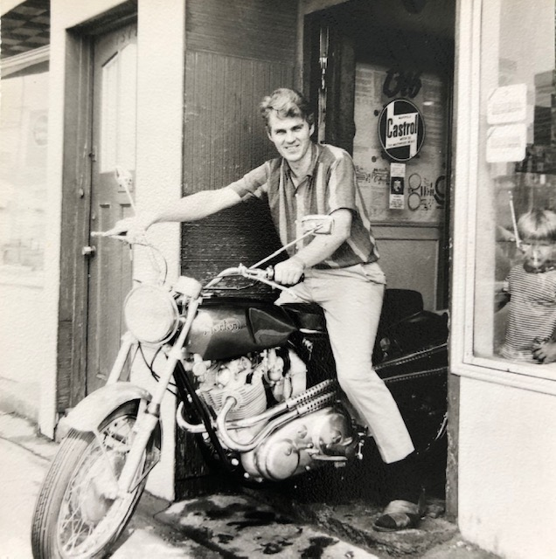

Gerry leaves his beloved and devoted wife Jann (Robinson) and son Graeme (Julie Brown), and grandchildren. He was predeceased by his son Jay. He was born under the big skies of northern Alberta and raised in Winnipeg by parents Clement Lavalley and Frances (Trueman).

He was a giant of a man. All who knew him were graced by the privilege.

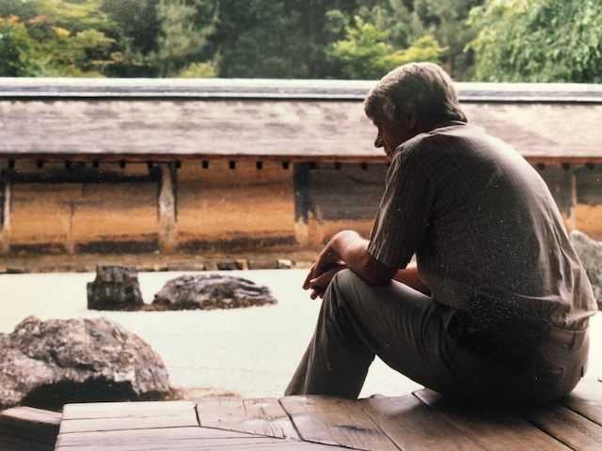

Gerry at Ryoanji Temple, Kyoto, Japan Penny Stewart

